IPL Analysis Dashboard (2008–2025)
Power BI Project Documentation

Submitted By
Kowsalya
MBA – Business Analytics

Project Title
IPL Analysis Dashboard (2008–2025) using Power BI & DAX

Abstract
The IPL Analysis Dashboard (2008–2025) is an interactive Power BI project developed to analyze Indian Premier League data across multiple seasons. The dashboard provides meaningful insights into team performance, player statistics, match outcomes, season winners, Orange Cap and Purple Cap achievements, venue analysis, and points table standings.
The project uses Power BI, DAX measures, data modeling, and dynamic visualizations to transform raw IPL datasets into an interactive analytical dashboard. Users can select any IPL season from 2008 to 2025 using slicers and instantly view season-specific insights.

Objectives of the Project
- To analyze IPL data from 2008 to 2025.
- To create an interactive Power BI dashboard.
- To provide season-wise insights dynamically.
- To analyze team performance and player statistics.
- To visualize Orange Cap and Purple Cap holders.
- To generate dynamic points tables using IPL rules.
- To improve business intelligence and data visualization skills.

Business Requirements
Primary KPIs
The dashboard dynamically displays:
- Winner Team of the selected season
- Winner Team Logo
- Runner-Up Team of the selected season
- Runner-Up Team Logo

Secondary KPIs
The dashboard dynamically displays:
- Total Sixes
- Total Fours
- Total Matches Played
- Total Teams Participated
- Total Centuries
- Total Half-Centuries
- Total Venues Used

Season Statistics
Orange Cap Statistics
- Orange Cap Holder Name
- Total Runs Scored
- Team Represented
- Dynamic Player Image
Purple Cap Statistics
- Purple Cap Holder Name
- Total Wickets Taken
- Team Represented
- Dynamic Player Image
Most Fours Statistics
- Player Name
- Total Fours
- Team Name
- Dynamic Player Image
Most Sixes Statistics
- Player Name
- Total Sixes
- Team Name
- Dynamic Player Image

Points Table
The dashboard dynamically generates a points table based on the selected season.
The table contains:
Field | Description
Logo | Dynamic Team Logo
Team Name | Official IPL Team Name
Matches Played | Total Matches Played
Won | Matches Won
Lost | Matches Lost
No Result | Rain affected/No Result Matches
Tie | Matches Ended in Tie
Total Points | Calculated using IPL Points Rules
IPL Points Formula
Total Points = (Wins × 2) + (Ties × 1) + (No Results × 1)

Tools and Technologies Used
Tool/Technology | Purpose
Power BI | Dashboard Development
DAX | Data Analysis Expressions
Power Query | Data Cleaning & Transformation
Excel / CSV | Dataset Source
Data Modeling | Relationship Management

Dataset Information
The project uses IPL datasets containing:
- Match-level data
- Ball-by-ball data
- Team details
- Player details
- Venue information
The dataset includes IPL seasons from 2008 to 2025.

Data Modeling
The project uses relationships between:
- Match Data Table
- Ball-by-Ball Data Table
- Team Data Table
- Player Data Table
Relationships were created using:
- Match IDs
- Team Names
- Player Names
- Season Columns
Key DAX Measures Used
Example Measures
Total Matches Played
COUNTROWS(ipl_matches_data)
Total Sixes
CALCULATE(COUNTROWS(ball_by_ball_data),
ball_by_ball_data[batter_runs] = 6)
Total Fours
CALCULATE(COUNTROWS(ball_by_ball_data),
ball_by_ball_data[batter_runs] = 4)
Purple Cap Holder
- Dynamic wicket calculation
- Excluding run-outs and invalid dismissals
- Season-wise filtering using slicers
Orange Cap Holder
- Dynamic run aggregation
- Highest scorer identification
- Team and image lookup integration

Dashboard Features
Interactive Features
- Season slicer/filter
- Dynamic KPI cards
- Dynamic team logos
- Dynamic player images
- Interactive charts and visuals
- Responsive dashboard layout

Analytical Features
- Team performance analysis
- Player performance tracking
- Match statistics analysis
- Boundary analysis
- Wicket analysis
- Season comparison

Dashboard Pages
Page 1 – Overview Dashboard
Contains:
- Winner and Runner-Up details
- KPI cards
- Orange Cap and Purple Cap statistics
- Most fours and sixes statistics
- Interactive slicers
- Team-wise points table
- Match statistics
- Win/Loss analysis

Screenshots
Main Dashboard
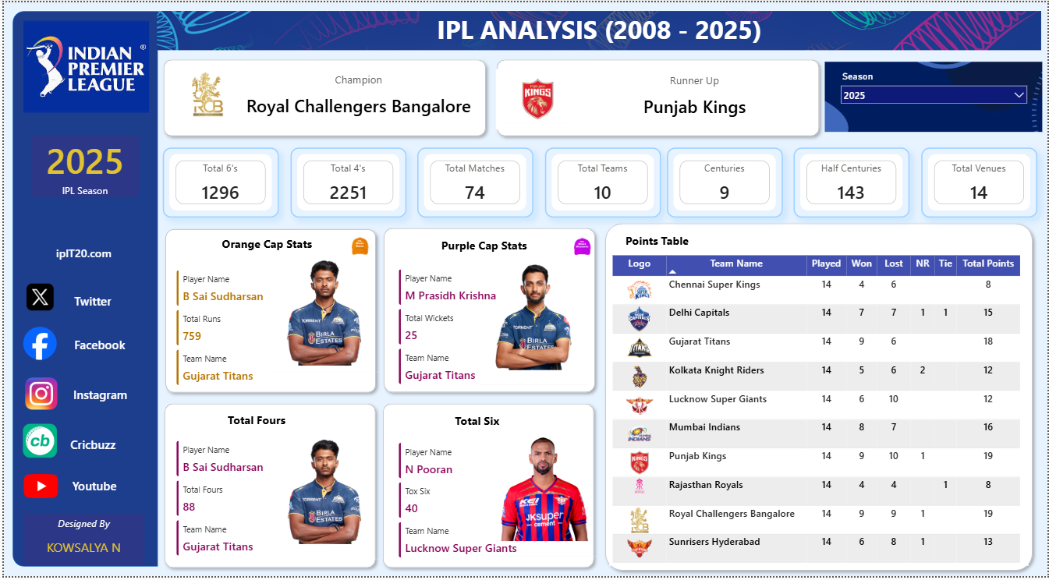Orange Cap Analysis
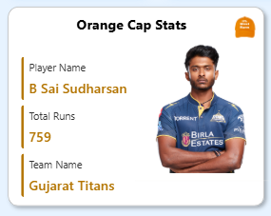
Purple Cap Analysis
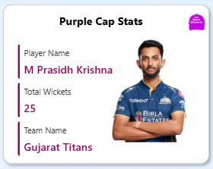

Points Table
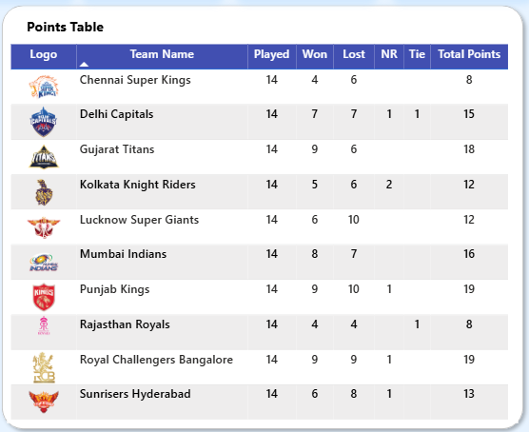

Challenges Faced
- Handling large IPL datasets
- Creating dynamic DAX measures
- Managing relationships between tables
- Dynamic image rendering in Power BI
- Designing responsive visuals
- Optimizing dashboard performance

Outcomes of the Project
- Successfully developed a fully interactive IPL analytics dashboard.
- Implemented dynamic season-wise analysis.
- Created advanced DAX calculations.
- Improved dashboard design and visualization skills.
- Enhanced business intelligence and analytical capabilities.

Learning Outcomes
Through this project, the following skills were improved:
- Data Cleaning
- Data Visualization
- DAX Calculations
- Dashboard Designing
- Business Intelligence
- Analytical Thinking
- Data Modeling
- Power BI Development

Future Enhancements
Future improvements may include:
- Predictive analysis using Machine Learning
- Live IPL API integration
- Advanced player comparison dashboards
- Mobile optimized dashboard design
- AI-powered insights

Conclusion
The IPL Analysis Dashboard (2008–2025) successfully transforms raw IPL datasets into meaningful business insights using Power BI. The project demonstrates strong analytical, visualization, and data modeling skills through dynamic KPIs, interactive dashboards, advanced DAX calculations, and season-wise IPL analysis.
This project highlights the practical implementation of Business Intelligence concepts in sports analytics.

